Sign up for a Weird Science Day Camp Near you: <https://scoutingevent.com/296-WeirdScience2021>

* **Wadena** - Sunnybrook Park - July 13 - 5:30pm - 9pm
* **Sartell**- Council Office - July 21 - 4pm - 8pm
* **Becker** - Palmer Park - July 27 - 5pm - 8pm
* **Long Prairie** - Long Prairie Drive- In - Day Camp and a Movie- July 28 - 7pm - when movie is finished.
* **Paynesville** - Gazebo Park - Aug 11 - 4pm - 8pm
* **Melrose** - Sauk River park - Aug 21 - Noon - 4pm
* **Milaca** - Rec Park - Aug 28 - Noon - 4pm

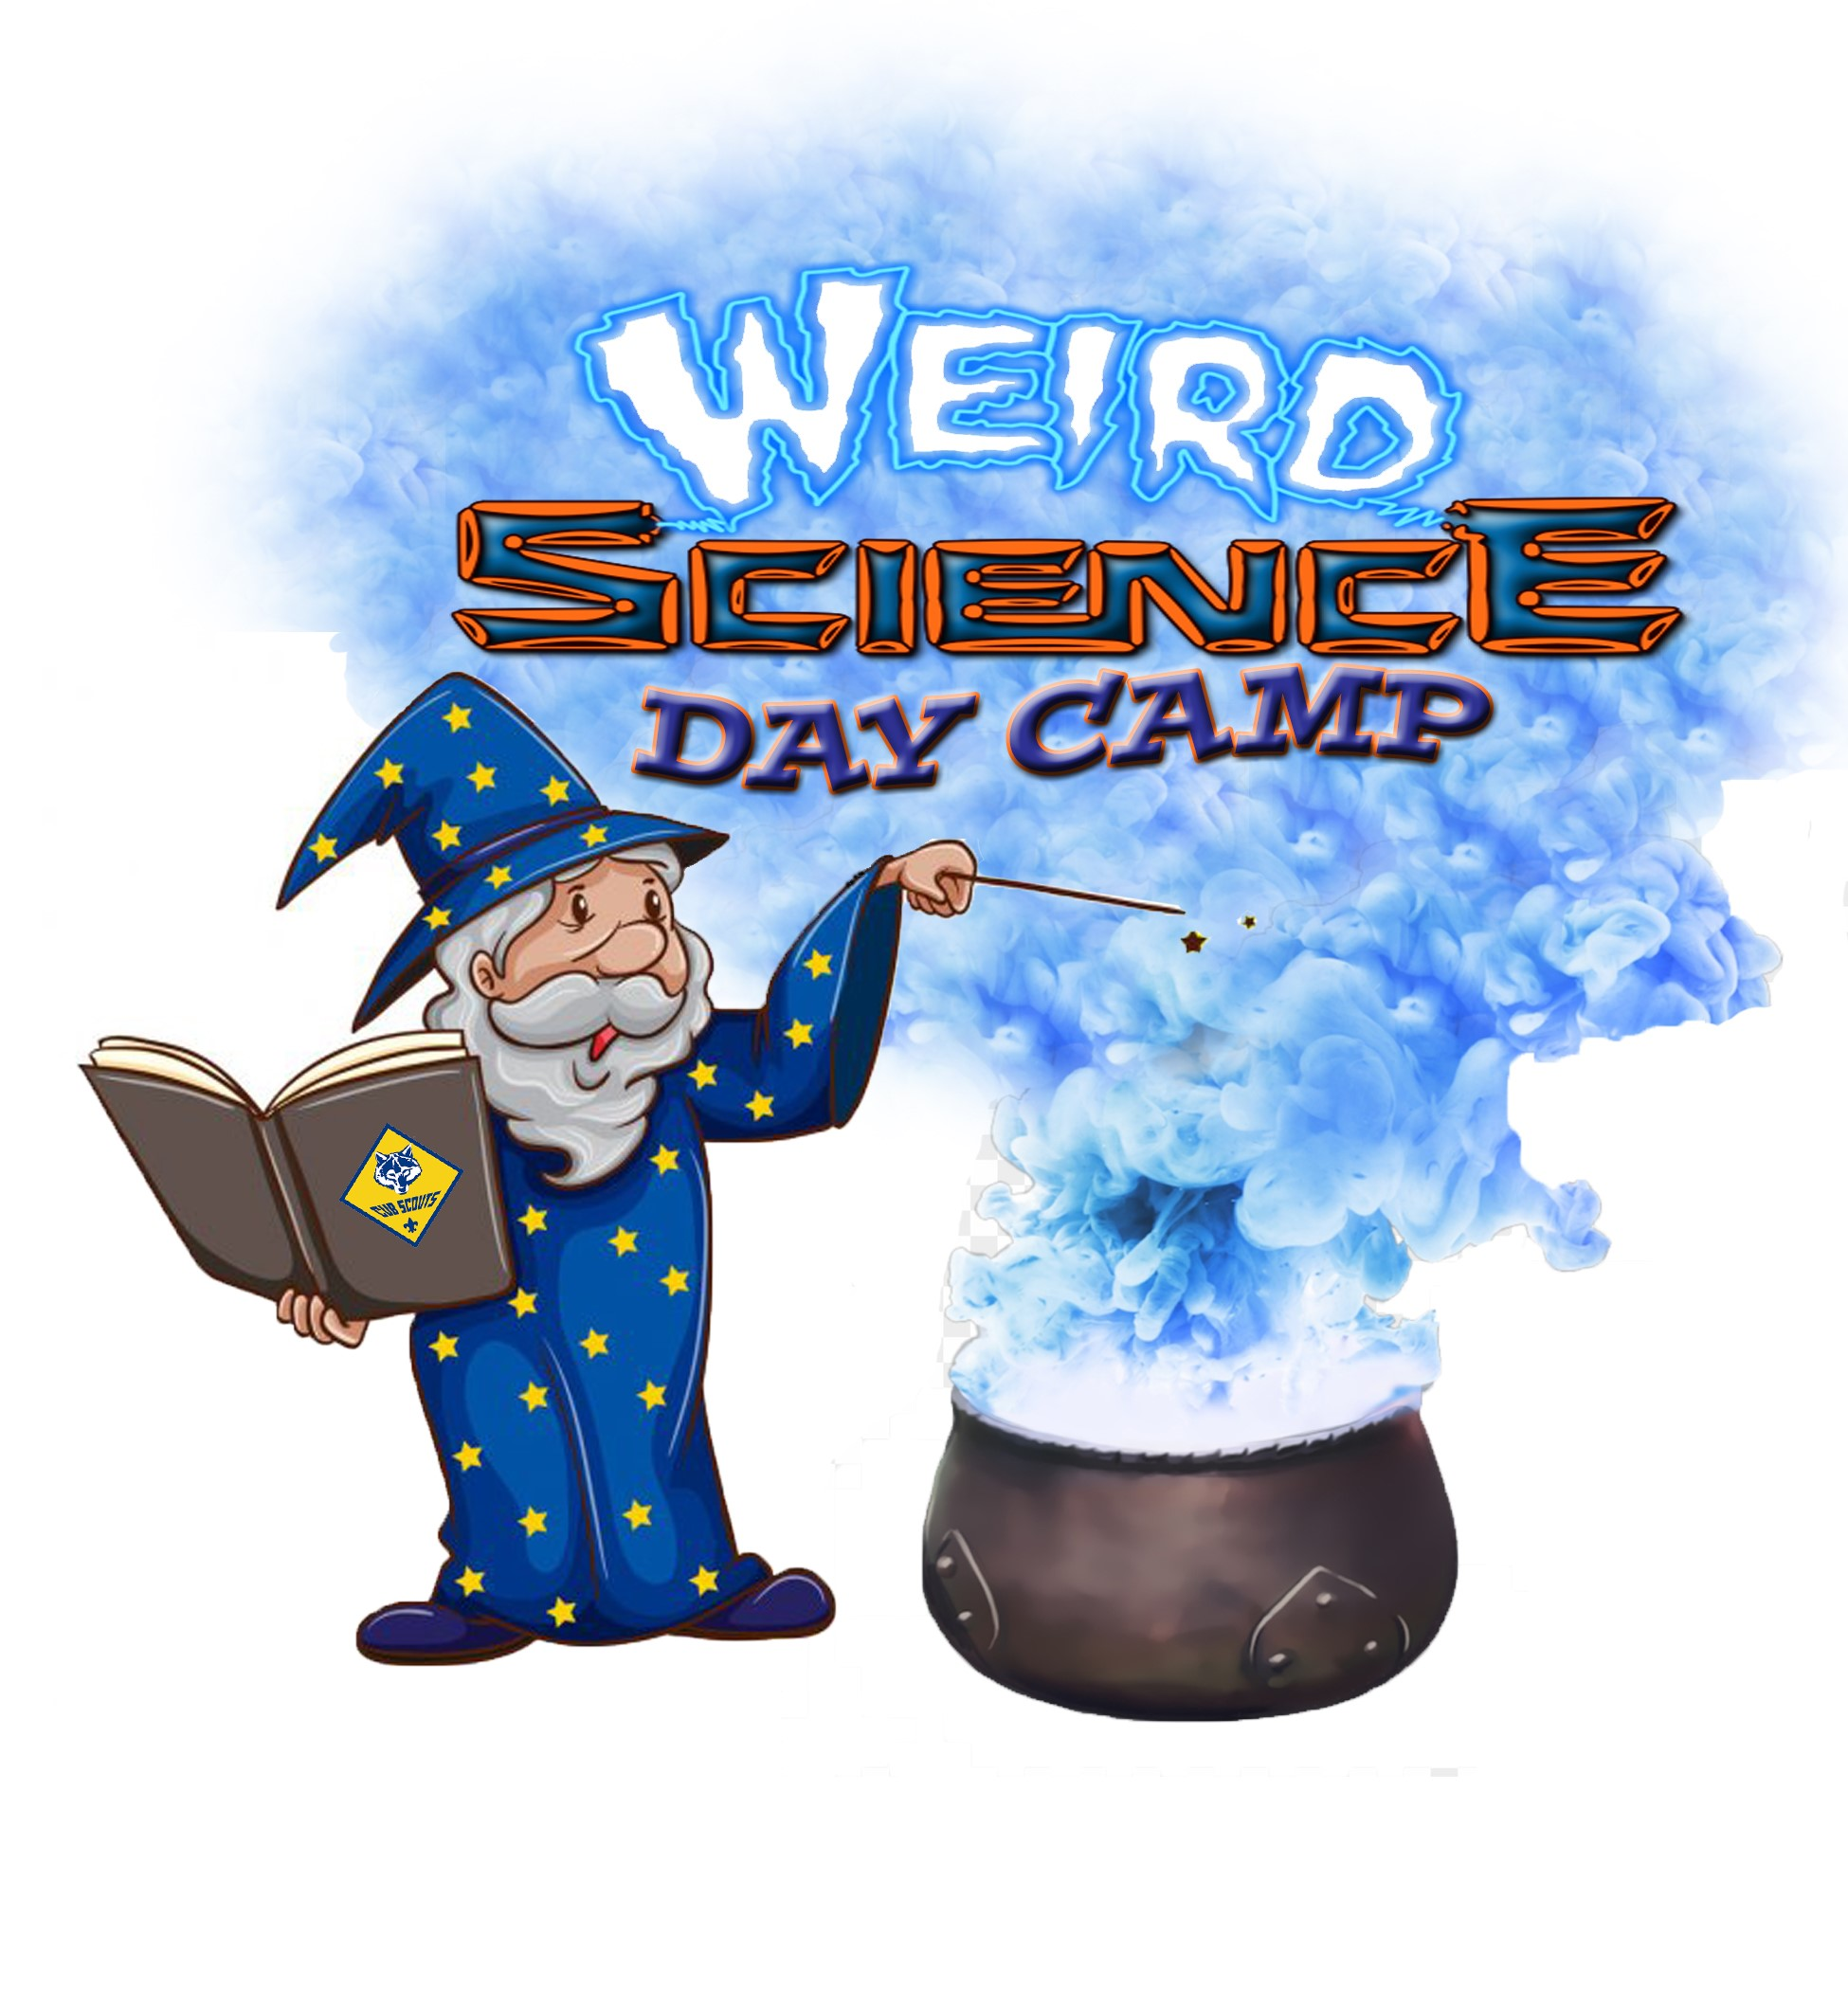

Coming Soon to a Community Near You!

Archery Crafts BB guns Games

Science Experiments