NANUQ 2021
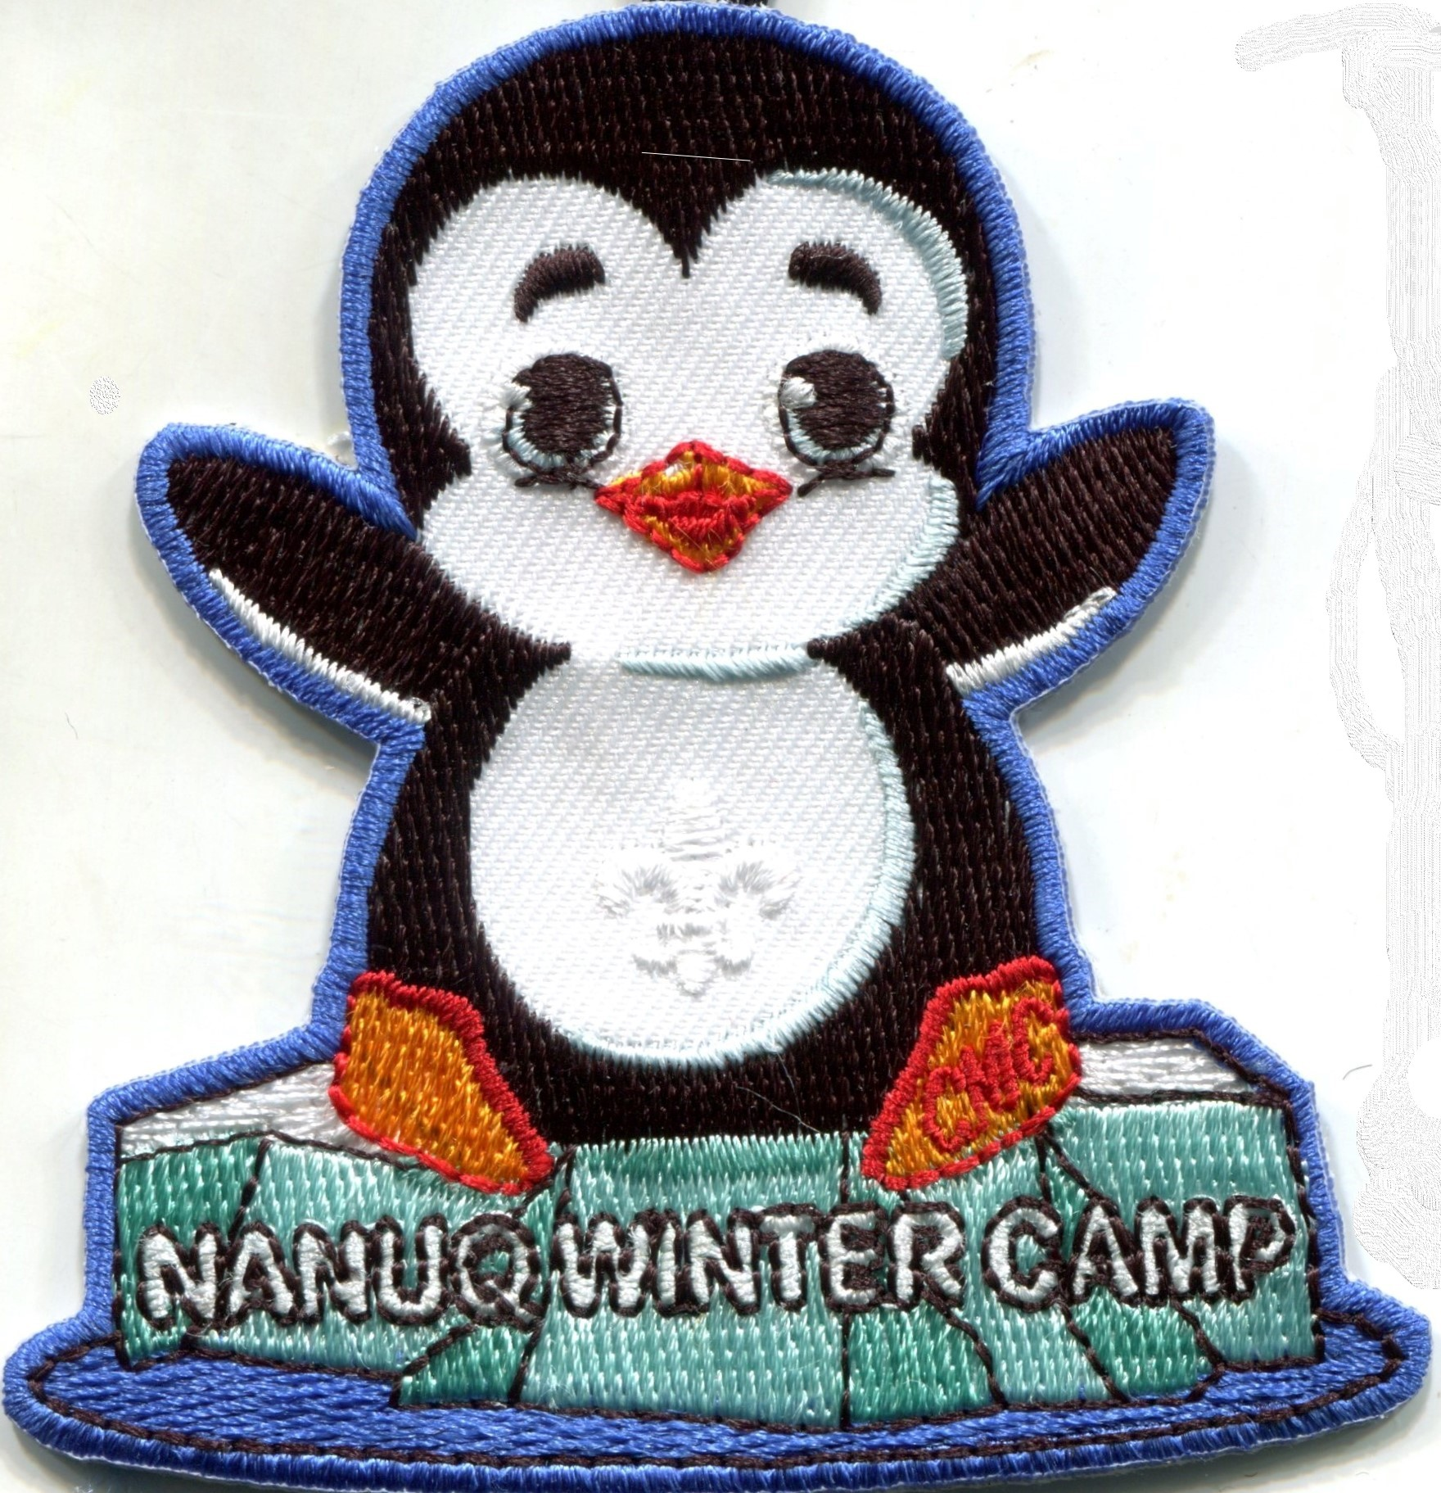
Parker Scout Camp, 21930 Paradise Dr. N, Nisswa, MN

Due to Covid-19 and that our goal is safety,
social distancing, and fun, this activity is going
to be a day camp with limited participation
and a unique overnight experience.
All spots are first come, first served.
Our numbers have been cut in half, so they will go fast!

Cost for Nanuq Day Camp is $45 per youth, $40 per adult, which covers food, supplies and activities, and a new patch this year for the Scouts!!
Register by December 1 and get $5 off per person.
Health forms for youth and adult are required for all Scout events. The Covid waiver and pre-screening forms found in the attachments will be required.
You can find the links in attachments on the registration site.
Camp Nanuq is a winter Cub Scout program based out of Miller Castle on the Parker Scout Camp property. Campers will arrive Saturday morning, raise the flags, get oriented for the day, and then get ready for some outdoor fun!
Snowshoeing, cross-country skiing, winter games, broom ball and/or koob, and ice fishing. You can also enjoy games or learn how to operate an Ollie Robot!
(You can download a free app for your smart phone from Sphero, Ollie, prior to camp, wi-fi reception is minimal in the castle. This program will allow you to operate an Ollie.)
We will warm up with a hot Saturday lunch and end our day with dinner and a movie before you depart for home.
New this year is the opportunity to "rent" one of four family rooms for either Friday or Saturday night, for an extra $50, which includes movie, popcorn and breakfast for a family unit.
Bring your outdoor clothing and socks or slippers for indoors. Meals, equipment and supplies are provided.
This day program can accommodate 16 Scouts and 16 adults on each of the six weekends. Camp runs 6 weekends from January 9 thru February 20. (no Nanuq on February 6, Scout Sunday weekend)
Cub Scouts and Webelos to adult ratios are 4 to 1 with a minimum of 2 deep leadership, or parent and child. Your registration will not be confirmed until it is submitted! Please be prepared to enter names of all youth and adults, so that you can complete your registration to guarantee your spots!
Registration link is at www.bsa.cmc.org! Call 320-251-3930 for more information.

