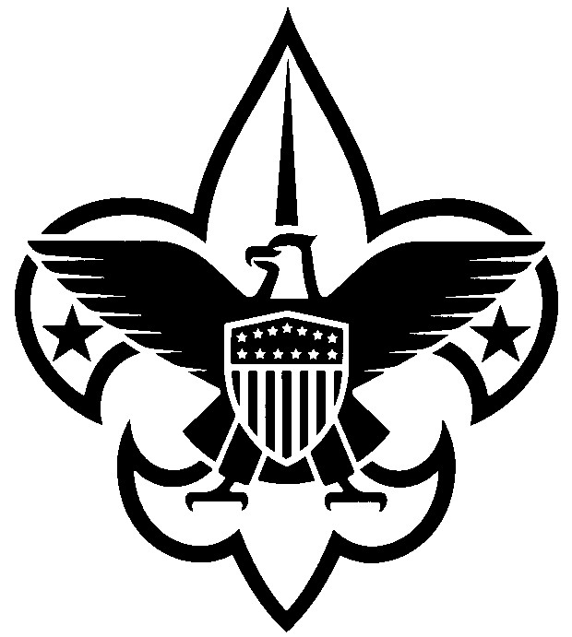
Annual Council Registration Form
(January 1, 2022 – December 31, 2022)

Dear Scouter: Your annual registration as a council volunteer is due. Please complete the form below and return to the Scout office with the appropriate fee. If you are currently registered as a primary in the council or as a multiple with a district/unit, no adult application is required.
If you wait to complete this process until December 31, 2021, an adult application must be completed.

Name _________________ Date of Birth _________________

Address ______________________________________

City _________________ State _____ Zip Code __________

Home Phone _________________ Work Phone _________________

Cell Phone _________________

E-mail _________________

District If Applicable

Council position(s) _________________

*Required Youth Protection Training Date Completed: _________________

Enclosed:
☐ $45.00 annual registration fee (An adult application must be submitted if you are new to the council staff.)

☐ $9.00 Insurance Surcharge

☐ $12.00 Boys’ Life subscription (optional)

☐ $0.00 (My primary registration is at the unit/district level Enter unit # or District
Also serving on council staff.)

_____ Total enclosed

___________________________________ ___________________________________
Scout Executive’s Signature Council Committee Member’s Signature
Mail to:
Central Minnesota Council, BSA
1191 Scout Drive
Sartell, MN 56377

