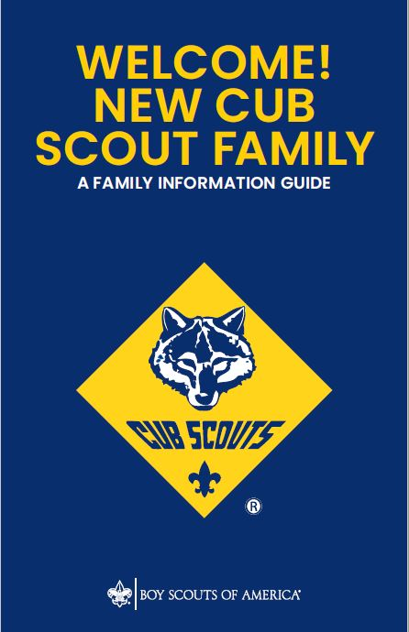
Central Minnesota Council
Why Join Cub Scouting?
• If you could give only one gift to the young people who are most important in your life, what would it be? No matter what your family situation is, it is within your power to help these children grow into people with a good feeling about themselves and a genuine concern for others. Cub Scouting can assist you in providing this greatest gift of all.
• Cub Scout-age children benefit developmentally from belonging to a small group of peers. Your child will be a part of a den, a small group of Cub Scouts in the same grade level and who are of the same gender. Through this sense of belonging, children build self-esteem and learn to get along with others.
• As a parent, you want to be assured that the groups that your child joins will teach values consistent with good citizenship, character development, personal fitness, and leadership. The values we seek to instill are found in the Scout Oath and Scout Law.
Scout Oath
A Scout is trustworthy, loyal, helpful, friendly, courteous, kind, obedient, cheerful, thrifty, brave, clean, and reverent.
Scout Law
On my honor I will do my best to do my duty to God and my country and to obey the Scout Law; to help other people at all times; to keep myself physically strong, mentally awake, and morally straight.
We know that kids do not join Cub Scouting for character building. Kids join because it is fun! Your child will learn great lessons, but they will be far too busy having fun to notice.
How Does Cub Scouting Work?
In Cub Scouting, you and your family join in on the program with your child, and you will help them along the way. Cub Scouts have a different handbook at each grade level, with adventures that are age-appropriate for their developmental level. As your child advances through these books by working on adventures, they will earn badges and other recognition that they wear on their uniform. As your child grows in Cub Scouting, your role will change with them, from hands-on involvement to guiding and coaching. Your child’s success in Cub Scouting depends on you!
The Cub Scouting program takes place at two levels. Your child will be a part of a den, a small group of Cub Scouts in the same grade level and who are of the same gender. A den typically meets twice a month, although some may meet more often. All dens, from kindergarten through fifth grade, make up a pack. Once a month, the dens, with their families, come together at the pack meeting and Cub Scouts are recognized for the adventures and badges they have earned.

New Cub Scout
Parent Orientation
Open House 2020

Please join us for this event to work towards earning your first Lion Adventure Loop (Kindergarteners) - Lions Honor, and older Scouts (1st - 5th graders) can work towards earning the first Cub Scout Badge - Bobcat! You will not want to miss this! Parents are strongly encouraged to attend and learn how to make the most of the Scouting experience.

When: Saturday, September 26th, 2020
10:00am to 1:00pm

Where: Sartell Scout Shop and Office
1191 Scout Drive, Sartell MN

What: Lions Honor and Bobcat badge activities for Scout and a parent meeting. Adults will learn your role as a parent and as a volunteer in your Cub Scout Pack. Parents are encouraged to enjoy activities with their Scouts.

Cost: FREE with “Scout Me In Golden Ticket” for new Scouts that registered after August 1, 2020.
Please pre-register so we have supplies on hand.
Sign up online at www.bsacmc.org

***Weather permitting, some Scout activities will be outdoors, and Scouts can take part in shooting sports activities and other events! The event is rain or shine. We will have events indoors if weather is questionable.

Bonus: Scout Shop will also be available for purchases!
Questions: Contact 320-251-3930

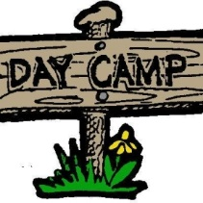
Mora Fall Fun Day
Saturday, October 3, 2020

Please join us for a day filled with lots of fun activities. You will not want to miss this! Parents are strongly encouraged to attend and learn how to make the most of the Scouting experience.

When: Saturday, October 3, 2020
10:00am to 3:00pm

Where: Mora Lions Park
For detailed information go to www.bsacmc.org

What: Scouts will participate in fun activities including BB Gun, Archery, Scout Skills, Crafts and much more. Adults will learn your role as a parent and as a volunteer in your Cub Scout Pack. Parents are encouraged to enjoy activities with their Scout.

Cost: $15/ Scout family
Free with the “Scout Me In Golden Ticket” for new Scouts that join after August 1, 2020
Please pre-register so we have supplies on hand.
Sign up online at www.bsacmc.org

***Weather permitting, the Scout activities will be outdoors, and Scouts can take part in some shooting sports activities and other events! The event is rain or shine. We will have events indoors if weather is questionable.

Questions: Contact 320-251-3930

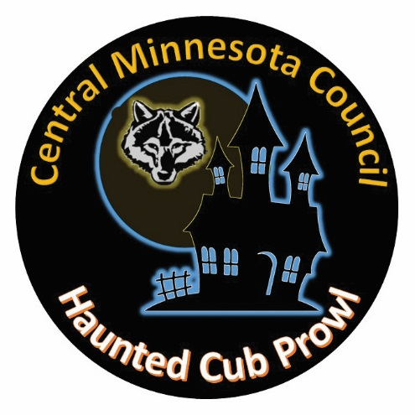
Haunted Cub Prowl
Come Have a Scary Good Time at Camp!!

What: Games, Sports, Crafts, Archery, Costume Contest, Haunted Castle Dungeon Maze, Prizes, Treats, Entertainment and tons of fun!!

Who: This event is open to all Scouts and family members.

When: Saturday, October 31, 2020 from 10am to 3pm (Check-in begins at 9:30am)

Where: Miller Castle - Parker Scout Camp 21930 Paradise Drive Nisswa, MN 56468
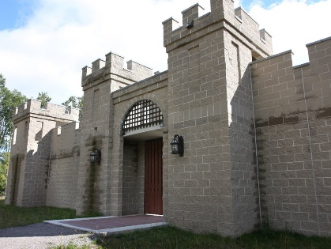
Fees: $15 per Scout or Free with “Scout Me In Golden Ticket”
$15 per non-Scout youth
$5 per Adult (covers the cost of lunch)

How: Sign up online at www.bsacmc.org

Registration fees are non-refundable, but may be transferred to another Scout.

Submit your registration by October 20th to ensure an adequate amount of supplies and food. Registrations after the deadline are subject to a late fee and are not guaranteed an event patch or lunch.

What do we bring?
Bring good footwear, clothing appropriate for the weather and a water bottle. Lunch is provided. Wear a costume to participate in the costume contest!

What about supervision?
This event stations will be staffed by district volunteers. Each Pack needs to provide at least 2 adults to accompany and adequately supervise their Scouts.
Adults attending should plan on being involved in the activities. Direct supervision of the scouts is the responsibility of the parents and adults attending from each Pack.

Health Forms
Complete and bring along Parts A & B of the standard BSA health form for each Scout can be found at: https://filestore.scouting.org/filestore/HealthSafety/pdf/680-001_AB.pdf
Questions? Contact…Ken Toole – kenneth.toole@Scouting.org - Phone: 218-780-0694

Lion Yowl & Tiger Prowl/Wolf Howl & Bear Growl
Who: Youth in Grades K-4th Grades and their parent or guardian.

What: Swimming, BB Guns, Complete Adventure Loop, Patch, Snack, and lots of Fun. Adventure Loops will be completely decided by August School Night for Scouting Training.

When: December 5th (See below for specifics).

Where: Foley High School

Register: www.bsacmc.org

Cost: $25 per youth for all events if signed up before November 22 (No Cost for Adults). $30 from November 23 to the day before the event. Limited spots available so register early.

Lion Yowl | Tiger Prowl | Wolf Howl | Bear Howl
Kindergarteners | 1st Graders | 2nd Graders | 3rd Graders
Saturday  December 5th  9am- 1pm | Saturday  December 5th  9am- 1pm | Saturday  December 5th  12pm- 4pm | Saturday  December 5th  12pm- 4pm
Foley High School, Foley, MN | Foley High School, Foley, MN | Foley High School, Foley, MN | Foley High School, Foley, MN
To Be Determined | To Be Determined | To Be Determined | To Be Determined
$25 early bird $30 after 11/22/20 registration closes December 2nd @11:59pm | $25 early bird $30 after 11/22/20 registration closes December 2nd @11:59pm | $25 early bird $30 after 11/22/20 registration closes December 2nd @11:59pm | $25 early bird $30 after 11/22/20 registration closes December 2nd @11:59pm

Dens
The Lion (Kindergarten) and Tiger (First Grade) Dens
Cub Scouts who join in kindergarten or first grade join with an adult partner, usually the parent or guardian. A Lion or Tiger den should be no more than eight Cub Scouts and their adult partners. An adult is selected to serve as the den leader (usually one of the parents) and coordinates the meetings. Each adult partner takes a turn assisting or hosting meetings or activities with the den leader. This shared leadership model is a great way to ensure the den leader has the help needed to deliver a quality program.
Lion dens (kindergarten) meet once a month or more often if the den leader and families choose to.
Tiger dens (first grade) meet typically twice a month or more often if the den leader and families choose to.
At den meetings, Lions and Tigers work on adventures that are found in their handbooks.
The Wolf (Second Grade) and Bear (Third Grade) Dens
Children this age are becoming more independent, and activities are designed to meet their developmental needs.
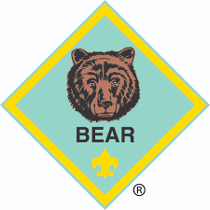
A Wolf (second grade) or Bear (third grade) den is ideally no more than eight Cub Scouts of the same gender, a den leader, an assistant den leader (usually parents of some of the den members), and often a den chief (an older Scout who helps the den leader).
They typically meet twice a month at a regularly scheduled time and place, and they also attend the pack meeting with their families
The Webelos Scout Den (Fourth and Fifth Grades)
The Webelos den is much like the Wolf and Bear dens, but there is more emphasis on learning to take leadership roles and preparing to join a Scout troop.

Pack Meetings
The Cub Scout pack is made up of all the dens, which meet monthly at the pack meeting, led by the Cubmaster. There are games, skits, songs, ceremonies, and presentations of achievements and badges that Cub Scouts earned during that month. This is where families can see the achievements of their Cub Scout.
The pack, including families, also participates in other special events throughout the year, including:
- Pinewood Derby®—You can build and race a model car with your child.
- Blue and gold banquet—Cub Scouting’s birthday party—for all pack members and their families— takes place in February.
- Camping—Overnight and day camp opportunities introduce your family to the camping experience.
- Service projects—Packs may participate in food drives, conservation projects, or other community activities.
- Field trips and special outings—Den outings are a great way to learn more about the people and places in your community.
Make memories with your child that will last a lifetime!
How Can You Help?
The most important help that you, as a parent, can give your child is to work with them on their Cub Scouting adventures as they work toward their badge of rank. The Cub Scout handbook is full of age-appropriate activities; some of them you do together at home. Den meetings are designed for Cub Scouts to complete adventures that are required for them to earn their badge of rank. When you have completed a requirement at home, make sure your den leader is informed so that they can properly record it and your child can be recognized for their achievements. Your role as a parent is the secret to a successful Cub Scouting program!
The den and the pack rely on parent participation to run a successful program. Cub Scouting operates through volunteer leadership. Volunteer leaders are an example of Scouting’s principle of service to others. By volunteering in Scouting, you are also giving your child and family the gift of your time. What could be more valuable? You will have an opportunity to be a positive influence in their life and in the lives of their friends. Here are some of the ways you could volunteer:
Den leader - Uses the Den Leader Guide and den meeting plans to lead the den at den meetings. Attends the monthly pack committee meeting.
Cubmaster - Helps plan and carry out the pack program with the help of the pack committee. Emcees the monthly pack meeting and attends the pack committee meeting.

The Pack Committee

Every Cub Scout parent or guardian is invited to become a member of the pack committee. Pack committee members perform administrative functions of the pack. The committee meets monthly and includes the responsibilities below.
Committee chair - Presides at all pack committee meetings. Helps recruit adult leaders and attends the monthly pack meeting and pack committee meeting.
Advancement chair - Maintains advancement records for the pack. Orders and obtains all badges and insignia. Attends the monthly pack meeting and pack committee meeting.
New member coordinator - Manages the transition of new Scouts into the pack and coordinates orientation for new Scouting families. Responsible for the marketing and recruiting initiatives of the pack as well as the growth and retention of the unit.
Secretary - Keeps records of the pack committee meetings and communicates with families about upcoming pack events and activities.

Treasurer - Keeps all financial records for the pack, including the pack bank account, and gives a monthly financial report to the pack committee. Attends the monthly pack meeting and pack committee meeting.

Training

The Boy Scouts of America offers convenient training for parents who volunteer. As a new parent, you can learn all about Cub Scouting and how quality Scouting programs are built. Log on to my.Scouting.org and create an account to gain access to all available training content. For more information about training at all levels of the program, go to https://www.scouting.org/training/.

Youth Protection
Child abuse is a serious problem in our society, and unfortunately, it can occur anywhere, even in Scouting. Youth safety is of paramount importance to Scouting. For that reason, the BSA continues to create barriers to abuse beyond what have previously existed in Scouting.
The Boy Scouts of America places the greatest importance on providing the most secure environment possible for its youth members. To maintain such an environment, the BSA has developed numerous procedural and leadership selection policies and provides parents and leaders with multiple online and print resources for all Scouting programs.
All leaders are required to complete Youth Protection training. All parents are encouraged to take the training. To complete the training online, go to my.Scouting.org and establish an account using the member number you receive when you register for BSA membership. If you take the training online before you obtain a member number, be sure to return to my.Scouting.org and enter your number for training record credit. Your BSA local council also provides training on a regular basis if you cannot take it online.
Youth Protection training must be taken every two years. If a volunteer’s Youth Protection training record is not current at the time of recharter, the volunteer will not be registered. For more information about Youth Protection, please see BSA’s Youth Protection website at https://www.scouting.org/training/youth-protection/.

How Much Does Scouting Cost?
- $66 Cub Scouts
- $25 One-time New Scout joining fee
- $42 Adult volunteers (includes cost of background check)
- $7 Council Fee
- $12 Boys Life Magazine (12 issues)
- ________ Pack Fees
Starting August 1, 2020, there will also be a one-time $25 joining fee for new program participants in Cub Scouts; however, there is no joining fee for adult volunteers. Fees chart below covers prorated $5.50/youth and $3.00/Adult monthly fee to register from month that you join through December 2021.

 | Scout Youth Fee |  |  |  | Adult Fee
Month- Year | Months | BSA National | Local Council | New Member with +$25 one- time fee | Months | BSA National | Council Fee | Adult Total
Aug 2020 - Dec 2021 | 17 | $93.50 | $7.00 | $125.50 | 17 | $59.50 | $7.00 | $66.50
Sep 2020 - Dec 2021 | 16 | $88.00 | $7.00 | $120.00 | 16 | $56.00 | $7.00 | $63.00
Oct 2020 - Dec 2021 | 15 | $82.50 | $7.00 | $114.50 | 15 | $52.50 | $7.00 | $59.50
Nov 2020 - Dec 2021 | 14 | $77.00 | $7.00 | $109.00 | 14 | $49.00 | $7.00 | $56.00
Dec 2020 - Dec 2021 | 13 | $71.50 | $7.00 | $103.50 | 13 | $45.50 | $7.00 | $52.50

Books: Youth handbooks are the Lion Handbook (comes with the Lion kit), Tiger Handbook, Wolf Handbook, Bear Handbook, and Webelos Handbook. Adult leaders use one or more of the following resources: The Cub Scout Leader Book, Lion Den Leader Guide (comes with the Lion kit), Tiger Den Leader Guide, Wolf Den Leader Guide, Bear Den Leader Guide, and Webelos Den Leader Guide. See your local Scout shop or www.scoutshop.org for prices and a wealth of other reasonably priced resources. Pack dues: The amount varies by pack, depending on money-earning projects conducted by the pack to decrease the amount needed to run the pack program. Uniform: The uniform and its cost vary by program for both youth and adults. Uniforms may also be purchased at your local Scout shop. See www.scoutshop.org for details and current prices.
Spending Time with Your Child: The Secret of Success!
Come join the fun of Cub Scouting as a family … it’s fun! You’ll make new friends, too, as you work with the parents of your child’s new friends. No task is too difficult when you’re having fun as part of a team of Cub Scout parents, reinforcing each other’s efforts to help your children grow up to be good citizens.

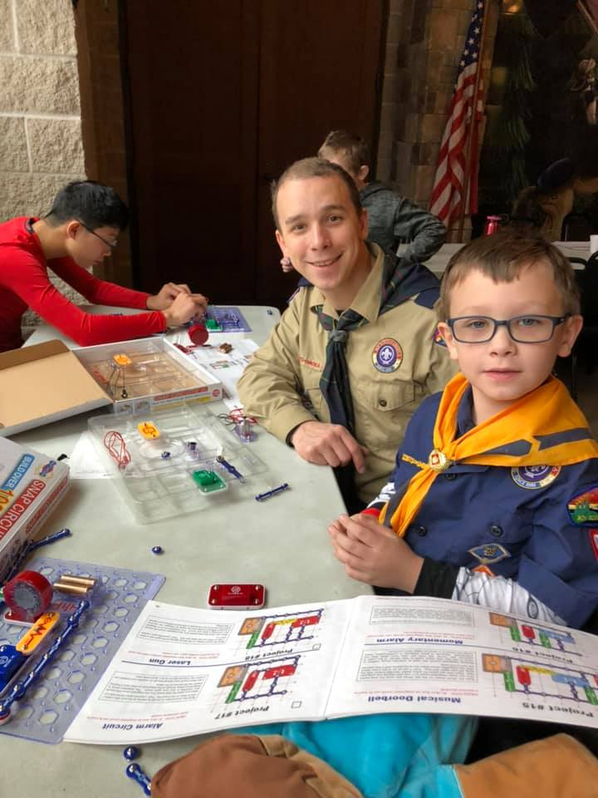
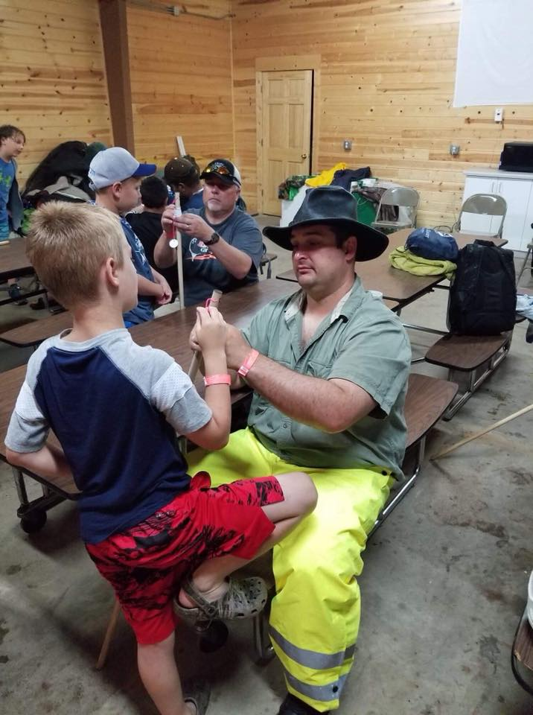

Adult Leader Training
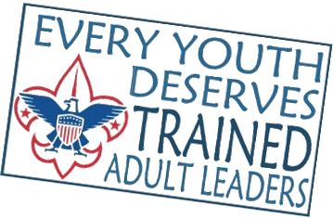
Once again, this year the Central Minnesota Council will be offering training opportunities for its new, as well as, experienced Adult Leaders. These training sessions serve as an excellent introduction for the new Adult Leader, and a beneficial refresher course for the experienced leader. For more information or to register go to: www.bsacmc.org

Virtual  Cub Leader Training  September 29, 2020  7- 8:30 pm  October 5, 2020  7- 8:30 pm  October 8, 2020  7- 8:30 pm  October 20, 2020  7- 8:30 pm | Virtual and In-Person  Scout Book Training  Troop Scoutbook  Sartell  September 1, 2020  7:30 – 8:30 PM  Pack Scoutbook  Sartell  October 6, 2020  7:30 – 8:30 PM
Roundtable Schedules (August – May)
Gateway Roundtable:  First Thursday of each month at  District Meeting: 6:30-7:00pm  Roundtable: 7:00-8:30pm  Trinity Crossing in Princeton. | Scenic Roundtable:  First Tuesday of each month  Commissioner Meeting: 6:30pm  District Roundtable: 7:00pm  Committee Meeting: 6:00pm Last Tuesday of the Month  Council Office in Sartell, MN.
North Star Roundtable:  Second Thursday of Each Month  Roundtable: 7:00 PM  Immanuel Lutheran Church in Wadena  403 2nd St SE, Wadena | Pine Tree Roundtable  Roundtable: 6:30 PM Second Tuesday of Each Month  District Meeting: 6:30 PM 1st Tuesday of Each Month  Salvation Army  Front and 5th Street, Brainerd
Cub Scout Events
Event Location Date
Cub/Webelos Summer Day Camp 5 Parker Scout Camp August 15, 2020
BALOO and IOLS Parker Scout Camp September 18 – 19, 2020
School Night for Scouting Local Elementary School September 24, 2020
Wood Badge Parker Scout Camp September 25-27, 2020
New Cub Scout/Parent Day Council Office September 26, 2020
Mora Mini Day Camp Mora (Location TBD) October 3, 2020
Webelos Activity Weekend Camp Ripley October 9 – 11, 2020
Wood Badge Parker Scout Camp October 17 – 18, 2020
Haunted Cub Prowl Parker Scout Camp October 31, 2020
Lion Yowl & Tiger Prowl Foley High School December 5, 2020
Wolf Howl & Bear Growl Foley High School December 5, 2020
Camp Nanuq 1 Parker Scout Camp January 9– 10, 2021
Camp Nanuq 2 Parker Scout Camp January 16 – 17, 2021
Camp Nanuq 3 Parker Scout Camp January 23 – 24, 2021
Camp Nanuq 4 Parker Scout Camp January 30 – 31, 2021
Scout Sunday Area Churches February 7, 2021
Camp Nanuq 5 Parker Scout Camp February 13 – 14, 2021
Camp Nanuq 6 Parker Scout Camp February 20 – 21, 2021
All District Pinewood Derby Various Locations March 20, 2021
Bear Webelos Lock-In SCSU March 27, 2021
Scout Expo Council Office April 10, 2021
BALOO Training Parker Scout Camp April 30 – May 1, 2021
Gateway Day Camp Elk River June 10 – 11, 2021
Cub/Webelos Summer Camp 1 Parker Scout Camp June 11 – 13, 2021
Cub/Webelos Summer Camp 2 Parker Scout Camp June 18 – 20, 2021
Cub/Webelos Summer Day Camp 3 Parker Scout Camp June 26, 2021
Cub/Webelos Summer Camp 4 Parker Scout Camp July 9 – 11, 2021
Cub/Webelos Summer Camp 5 Parker Scout Camp July 16 – 18, 2021
Cub/Webelos Summer Day Camp 6 Parker Scout Camp July 24, 2021
***All Events and locations are subject to change***
Check our website for the most updated information: www.bsacmc.org

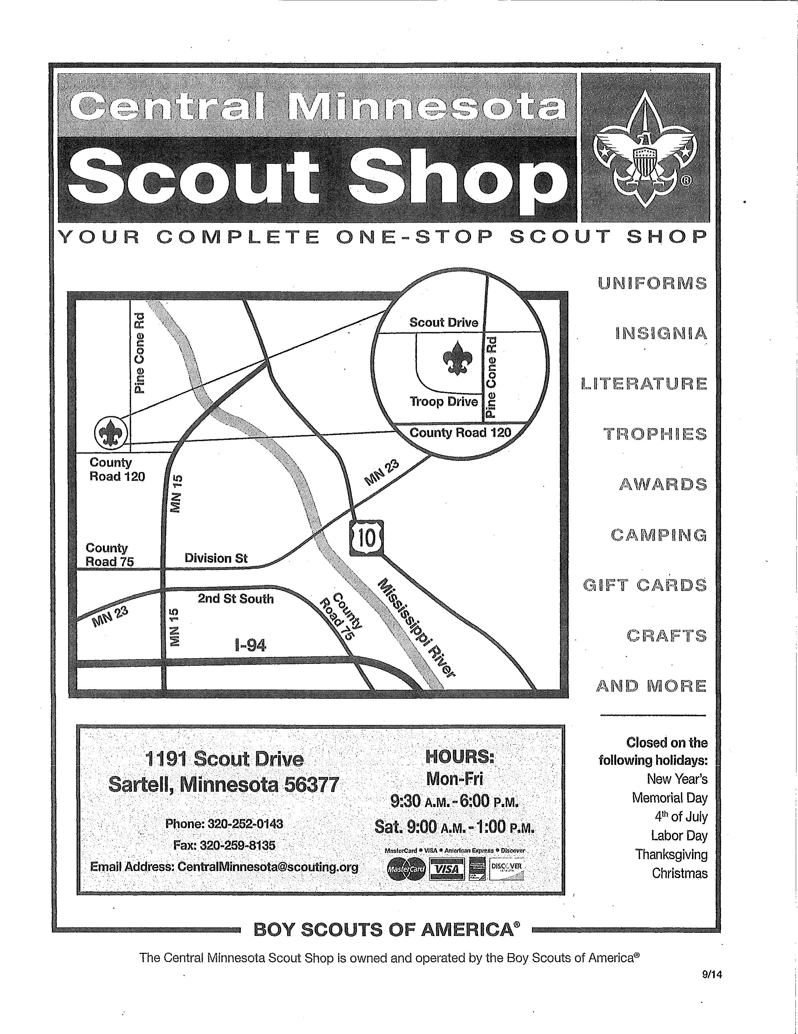
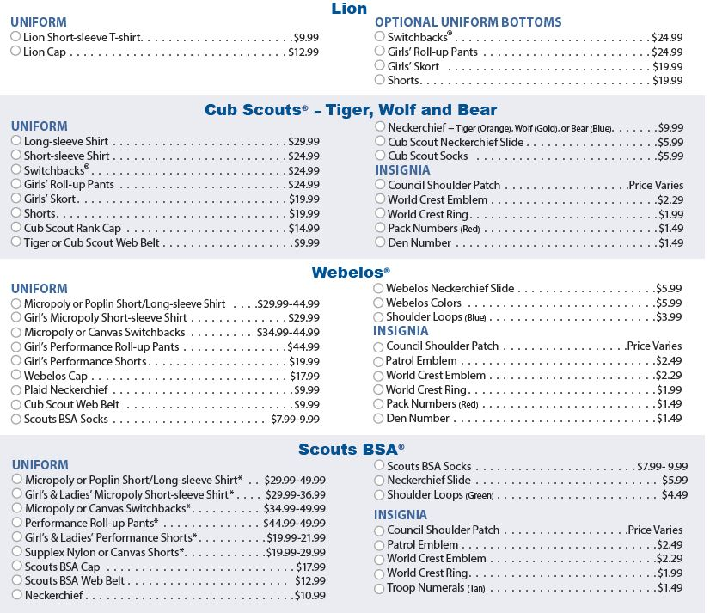
Central Minnesota Scout Shop
Phone: 320-252-0143 Email: CentralMinnesotaScoutshop@Scouting.org
Key Contact Information
Your Den is in a Pack that belongs to an organization chartered by the Boy Scouts of America (BSA) to operate a Scouting unit (a Chartered Organization). Chartered Organization approves leadership, helps secure a meeting place, and makes sure that the Pack works within the guidelines and policies of their organization as well as those of the BSA.
Your Pack is a member of a District, a geographic area of the BSA local council that helps support the Pack in providing a successful and high-quality program. An employee of the local council, a Unit-Serving executive (District Executive), is assigned to assist the Packs in your district.
Your district also has a volunteer team called the Commissioner Staff. They are a “service team” that checks on the program “health” of your Pack, and they are a communication link between your Pack and the local council. A Commissioner is assigned specifically to assist your unit.
All leaders need training to be effective. Your district provides online or instructor-led training for adult volunteers in how to be a successful leader. Your district is one of several in the BSA local council. your council service center can help or will get you in touch with someone who can.

My child is in Pack Unit Number, which meets at Location
At time of meeting on Day and Week of Month
My child is in Den Den number. which meets at Location.
At Time on day of week.
Our Pack’s Chartered Organization is: Charter Organization
Our Pack is in District: District.
Our local Council name is: _Central Minnesota Council, BSA.
Phone No: _320-251-3930 Website: _www.bsacmc.org
Position | Name | Phone No. | Email
Den Leader | Name | Phone Number | Email Address
Cubmaster | Name | Phone Number | Email Address
Committee Chair | Name | Phone Number | Email Address
Advancement Chair | Name | Phone Number | Email Address
Popcorn Kernel | Name | Phone Number | Email Address
District Executive | Name | Phone Number | Email Address
Unit Commissioner | Name | Phone Number | Email Address

