Central Minnesota Council
Internet Charter Renewal
2.0
User Guide

To Start Internet Recharter
Go to Internet Advancement (Advancement.Scouting.org), and log in using your existing Scoutbook.org/my.Scouting.org username and password.
Only the Unit Leader (Cubmaster, Scoutmaster, Venturing Advisor, Sea Scout Skipper, or Exploring Advisor), Charter Organization Representative, Committee Chairman, or a Key 3 Delegate have access.

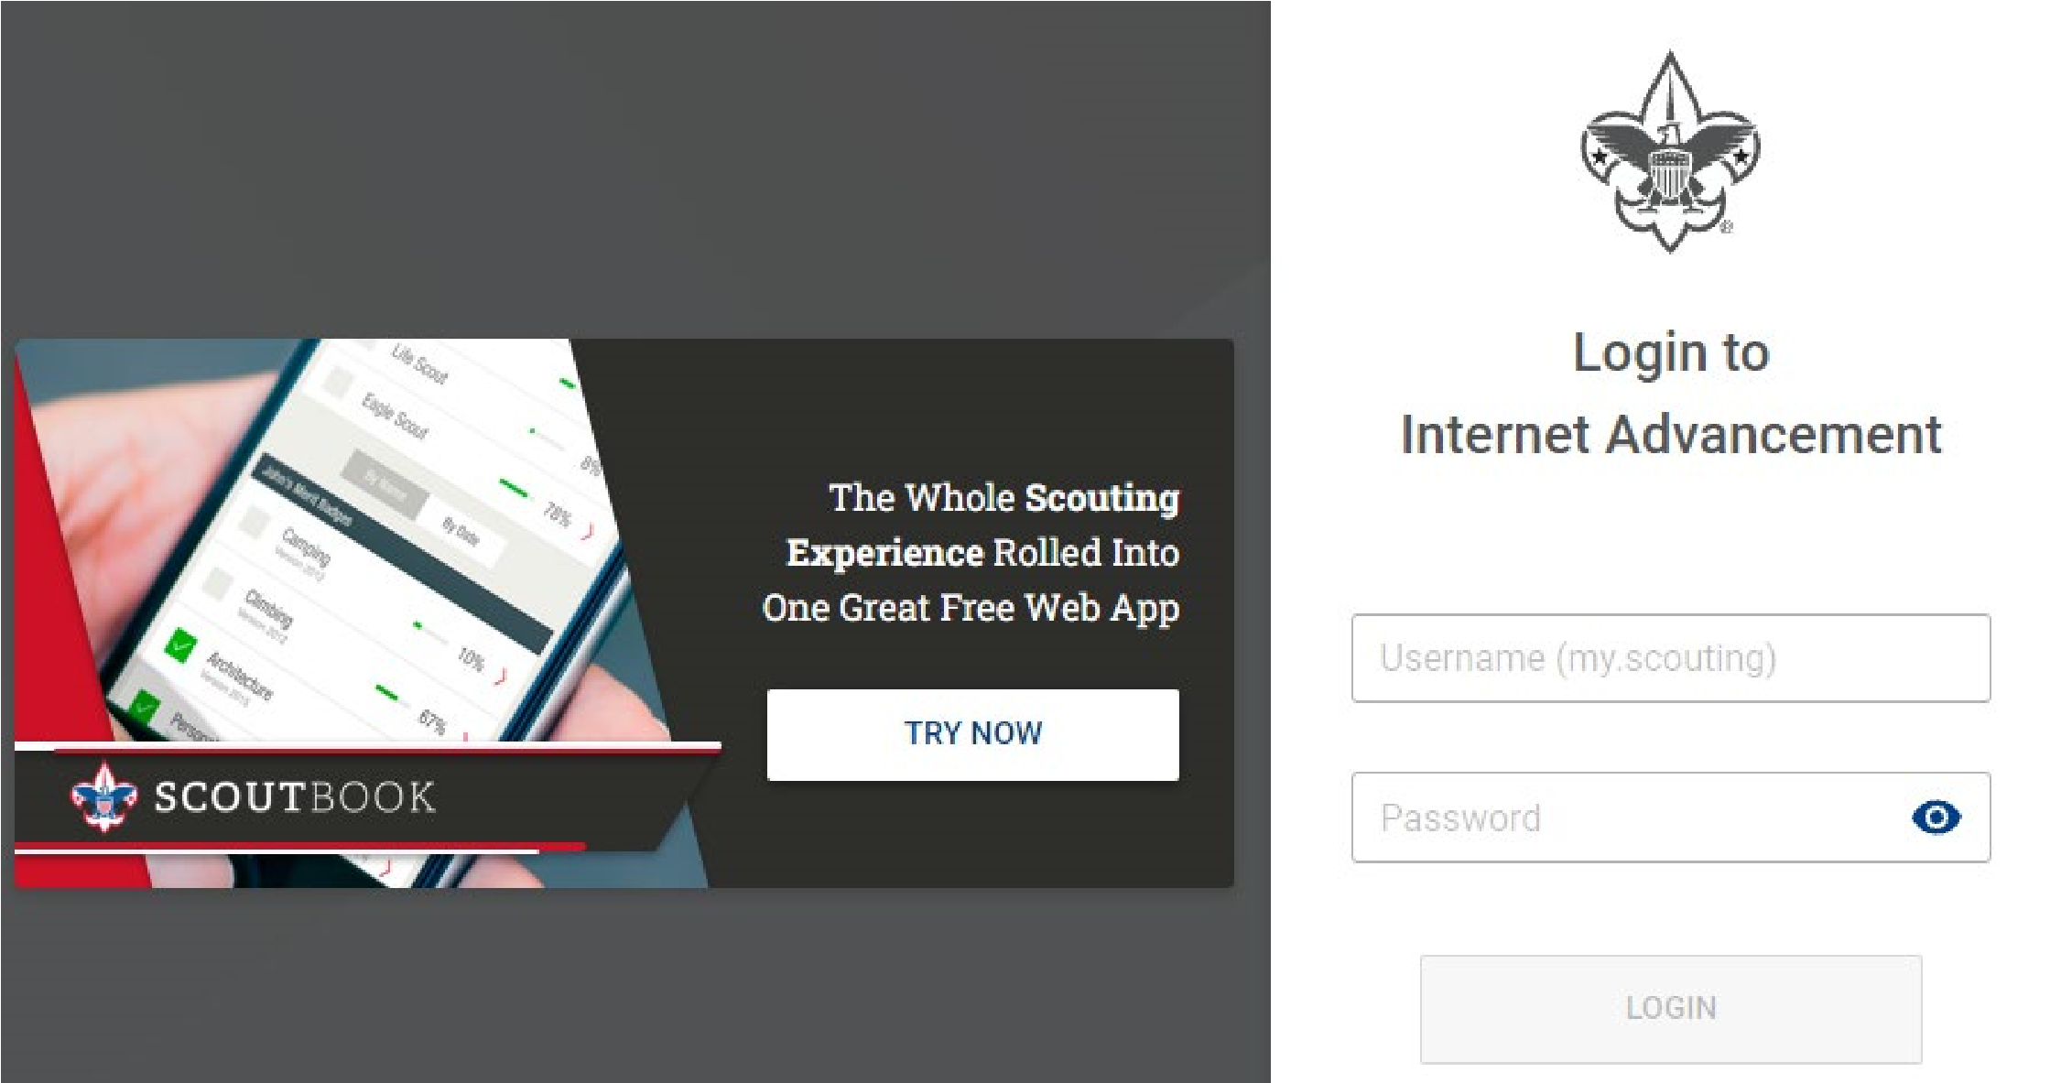

In Internet Advancement, select Recharter on the lower left.
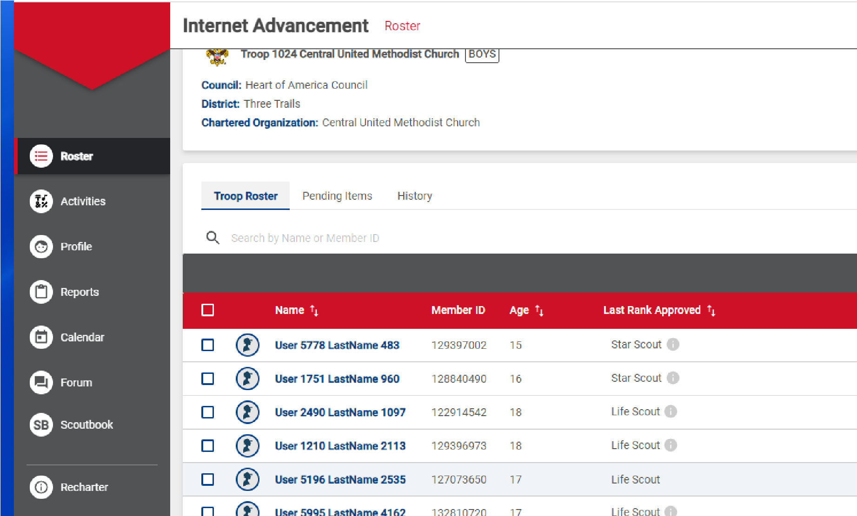

Unit details
Check your unit and chartered organization’s details.
If you find any issues, let the council know! (We can fix it.)
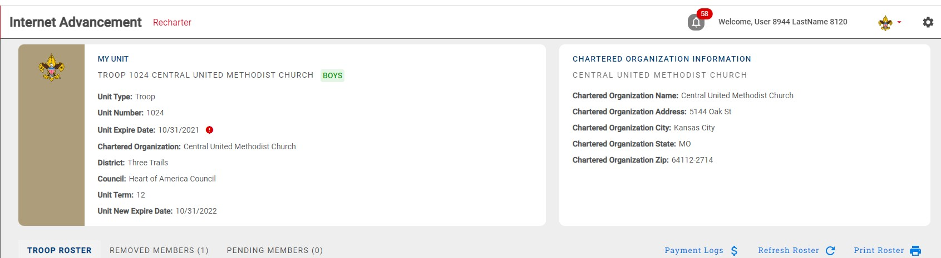

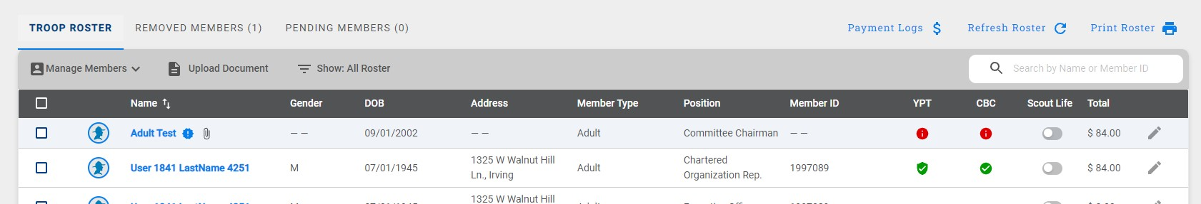

IMPORTANT REMINDER:

Refresh Your Roster Regularly!

This will update volunteer’s Youth Protection Training status, Criminal Background Check Authorization status, and add new
members.

Once the roster is loaded, you may start editing the roster:

What do the icons mean? You will use these icons throughout Internet Recharter

Select record – check the box to select the record (used for some menu items)

Age Category
Adult
Youth

YPT: Youth Protection Training status
Red Exclamation Point – they do not have current Youth Protection training
Green Exclamation Point – Youth Protection Training is current

CBC: Criminal Background Check
Red Exclamation Point – New Criminal Background Check Disclosure has not been received Note: this may be a data issue – check with your district executive
Green Checkmark – New Criminal Background Check Disclosure has been received

Scout Life
Grey (left) – no subscription included

Any column
No status recorded (new members, youth, or no fee adults – the Executive Officer, Lion Partners, and Tiger Partners)

Total
The fee your unit (pack, troop, crew, ship, or post) is going to be charged for this person in this position.

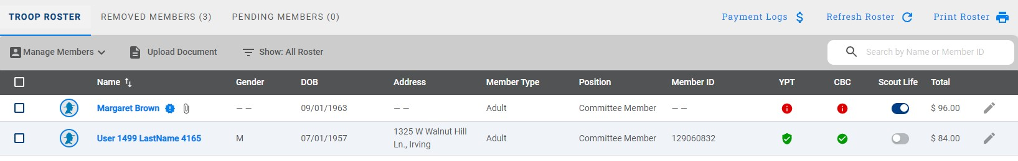

Changing a position

You can change the position of a leader by clicking on the pencil icon.
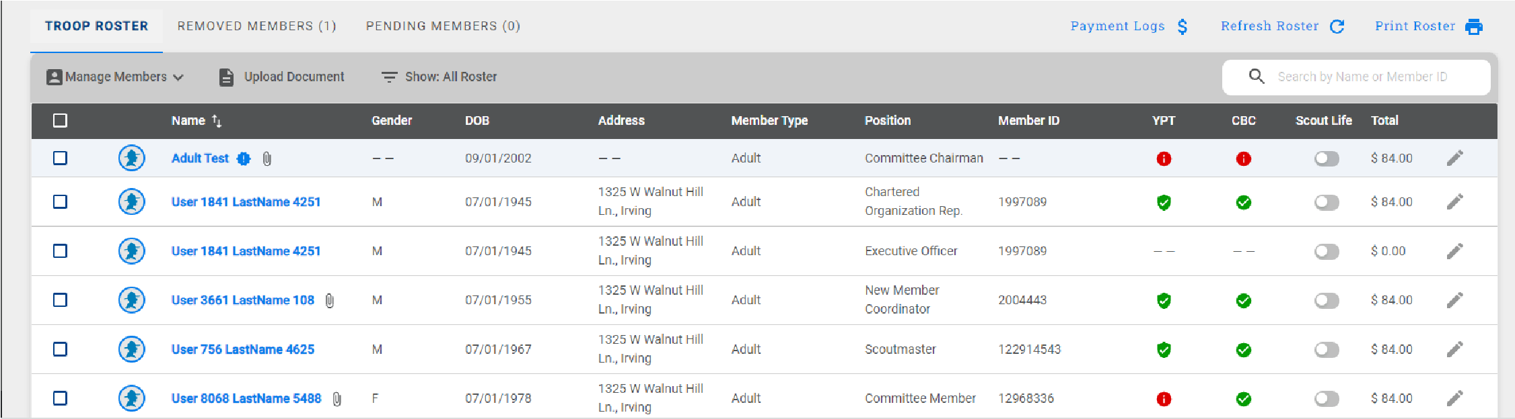

Choose the appropriate position from the drop down and click “Update Information”.
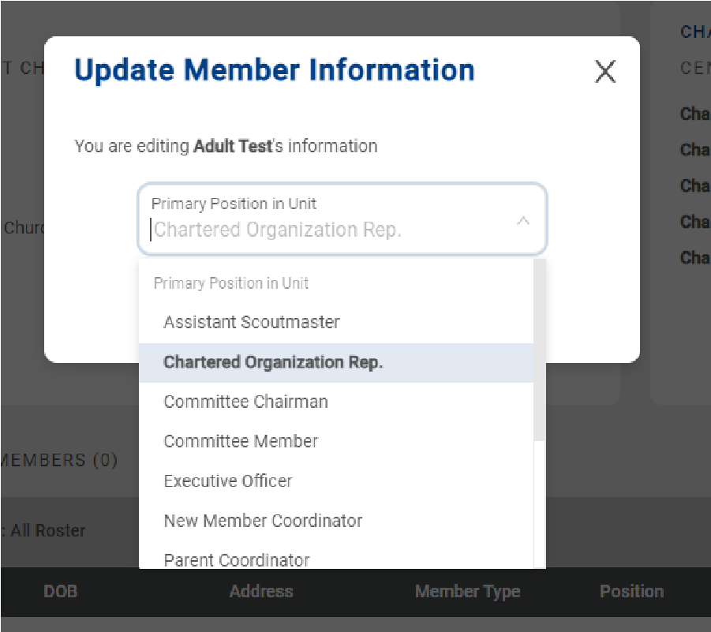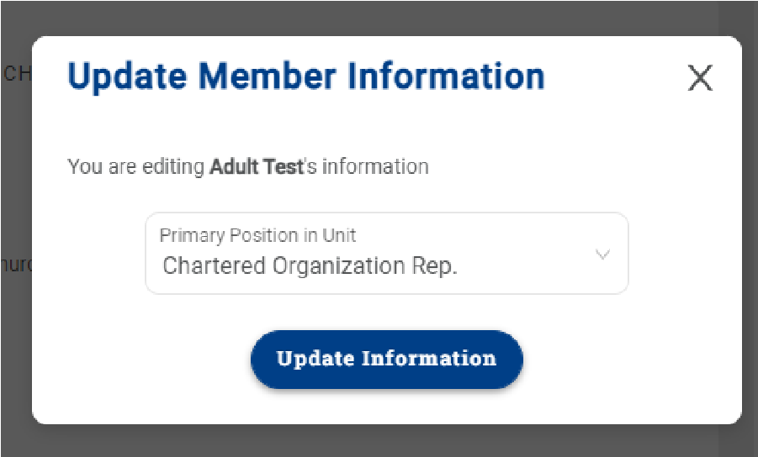

Manage Members Menu

Adding a New Member

Click on Manage Members

Add New Member

Complete the form (for an Existing Member, it will ask for Member ID instead of a paper application)

Click on the Plus sign next to Add Paper Application
• If the application is incomplete, the council will contact you about the issue.

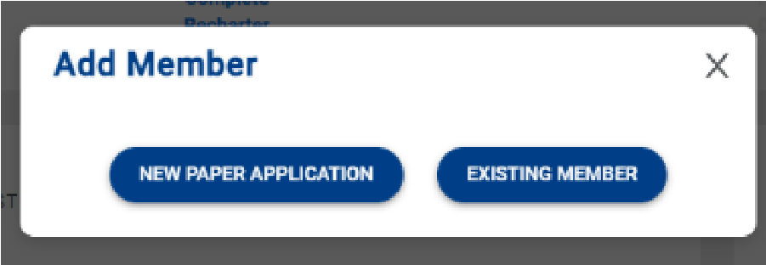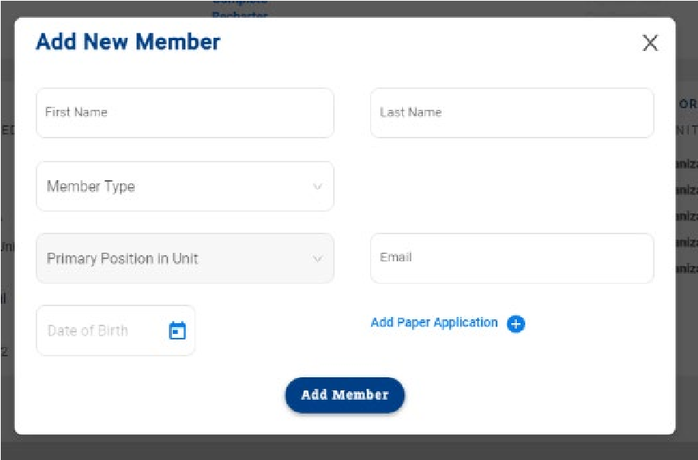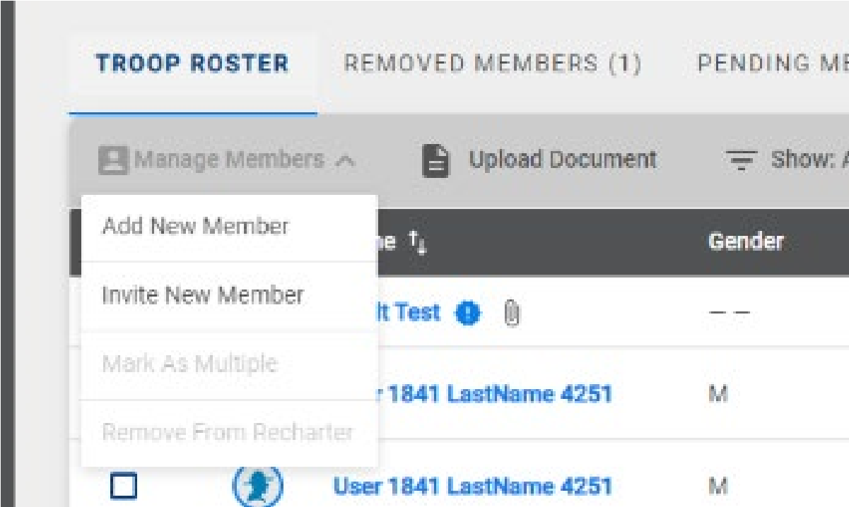
Click the Add Member button.

Uploading a Group of Documents into the Renewal
A group of documents (as a zip file*) can be uploaded into the renewal.

Select the individuals that you are uploading documents for Click upload documents
A popup will appear where you load the documents
• If you do not have the ability to upload the file, you can scan it as a PDF and email it to Membership@SeattleBSA.org or mail it to Chief Seattle Council (3120 Rainier Ave S, Seattle WA 98144)

When is a Youth Protection Certificate needed? Only if the volunteer is new. If Internet Recharter can’t find their current date, record it in my.Scouting.org’s Training Manager (then Refresh Roster).

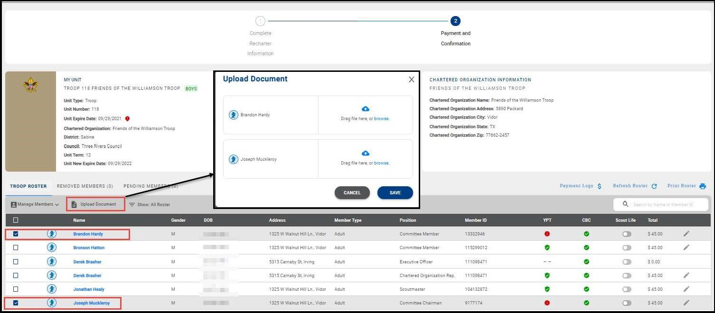

*See Appendix 1 for instructions on creating ZIP files.

Invite New Member into the unit (Leads)
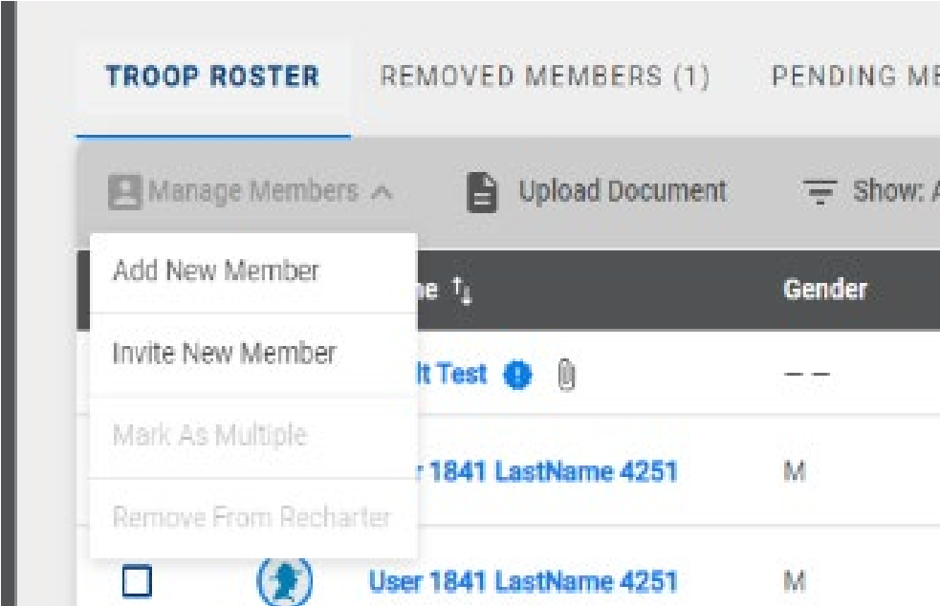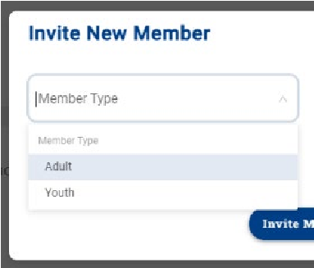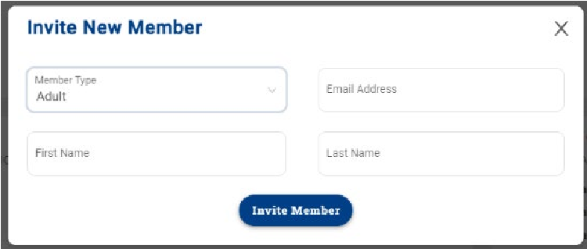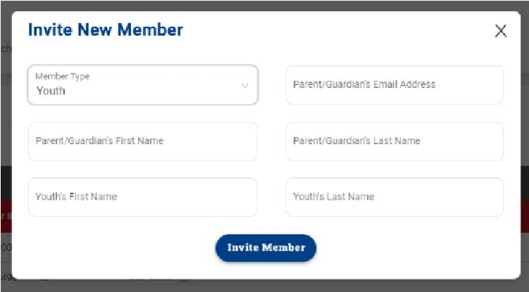

An email is sent with a link to complete an online application. Reminder: click on Refresh Roster periodically throughout processing your renewal. This will add any new online registrations into your unit. Once the invite is sent, they will appear on the Pending Members Tab.

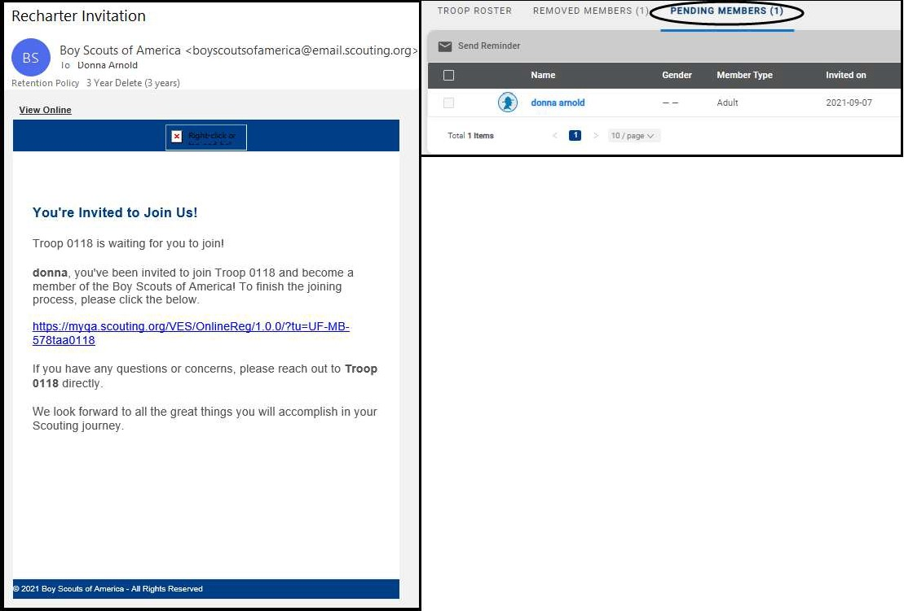

Designate a Multiple
Select the youth or adult(s) you want to mark as paid for in a different unit or on the district committee (everyone selected together must be paid for in the same place).
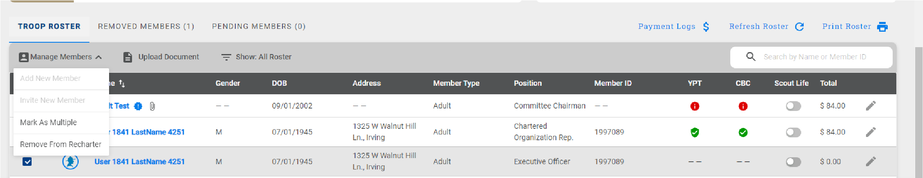

Identify the council (we are Chief Seattle Council), select unit type (Non Unit Position – used if they pay for membership at district), and unit number (it will show all council units).
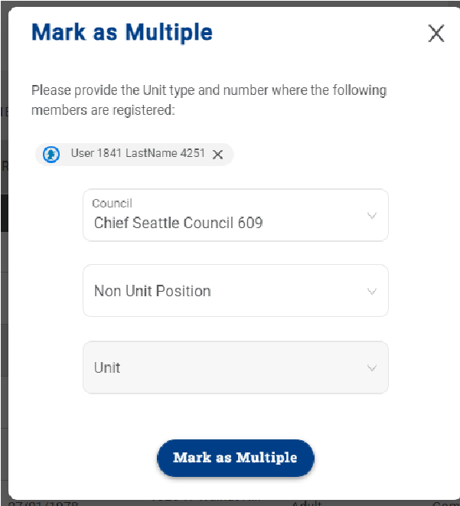

Remove From Recharter
Select the person(s) to be removed. Click on Manage Members and select Remove From Recharter. A popup will appear, and you will choose Remove. At that point they will be moved to the Removed Members tab.
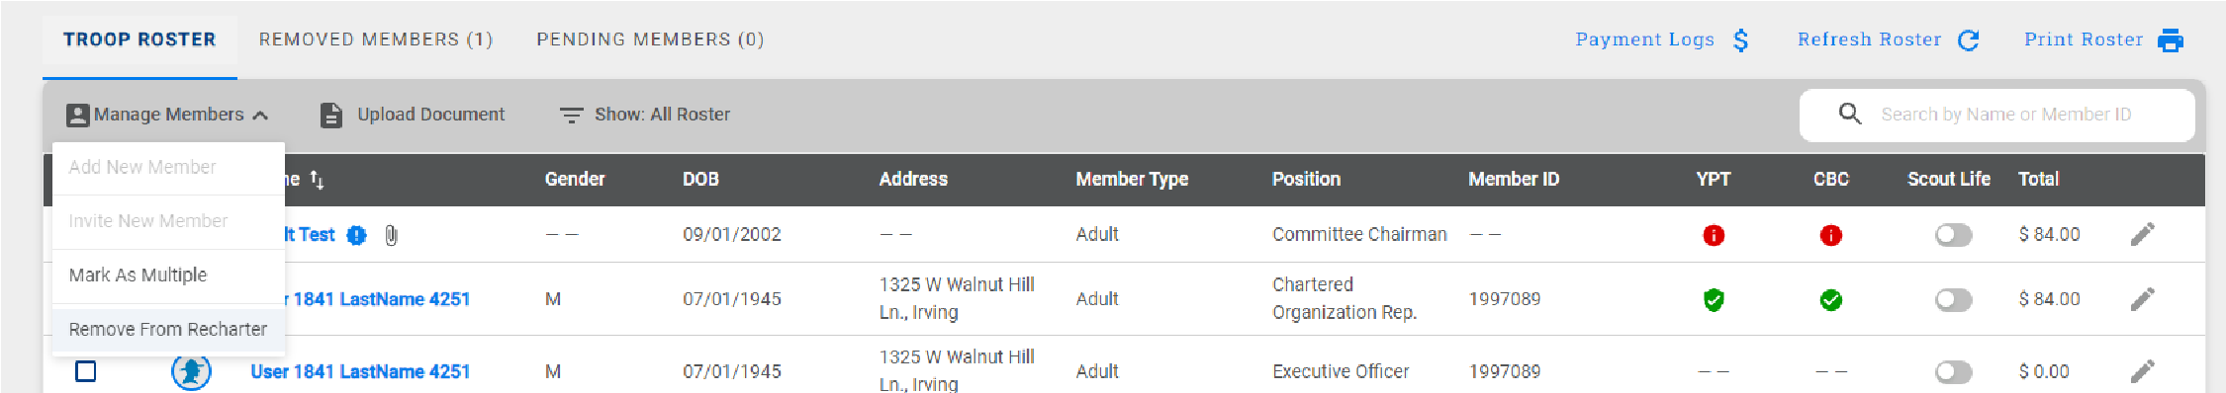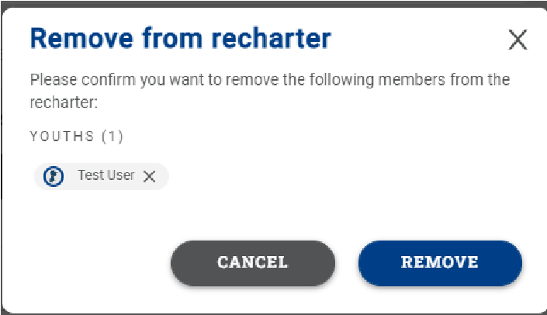

Adding An Individual Back to the Charter
Click on Removed Member tab
Check the box next to the person you are adding back into the unit Click Add to Recharter.
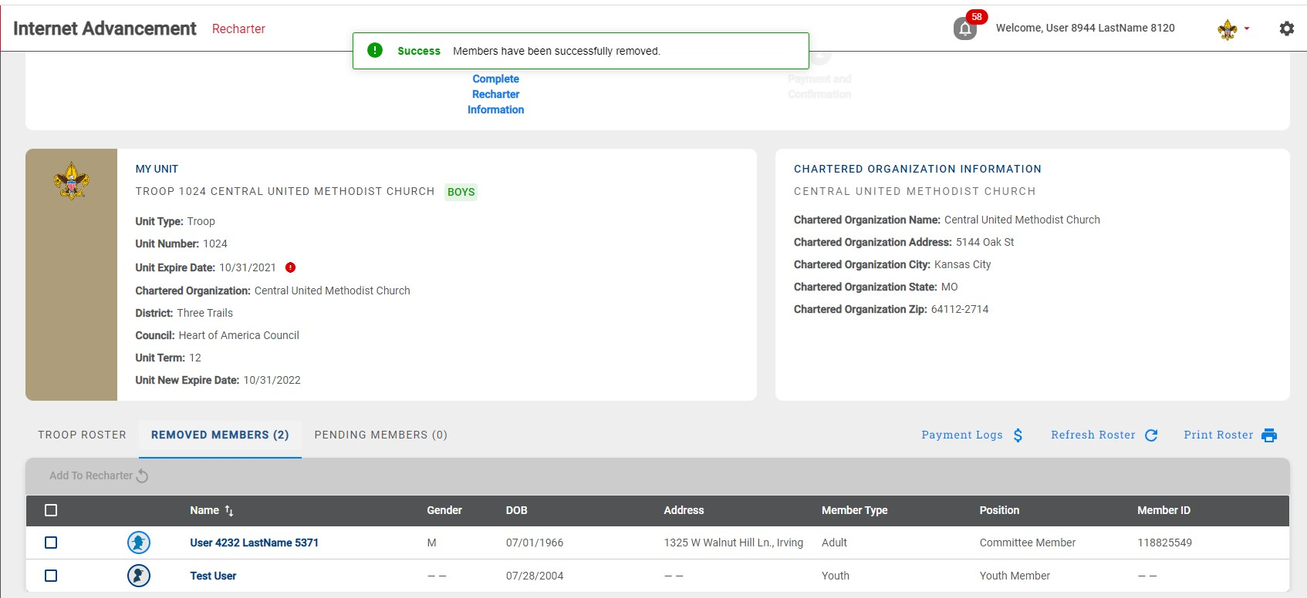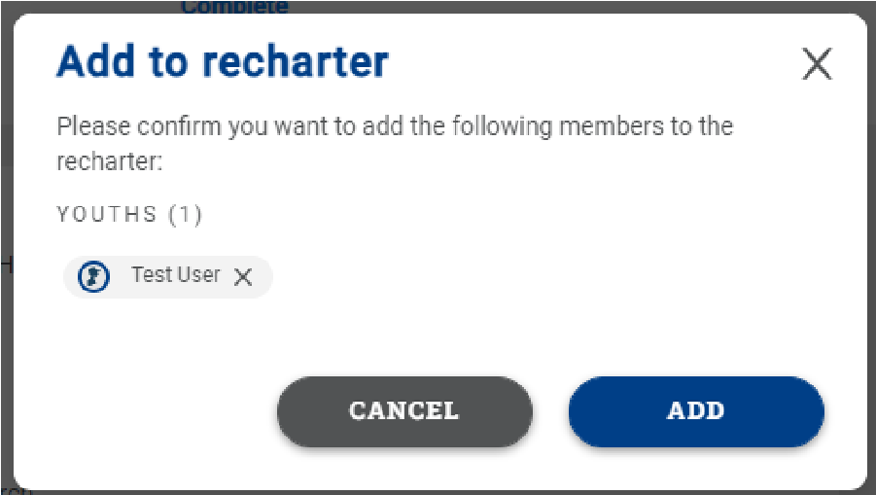
A pop-up box will appear - click
Add

Once you click Add, the youth or adult will move back into the unit. Click on the Troop Roster tab and the roster should now reflect the add. Once added, click Refresh Roster and continue with renewal submittal.
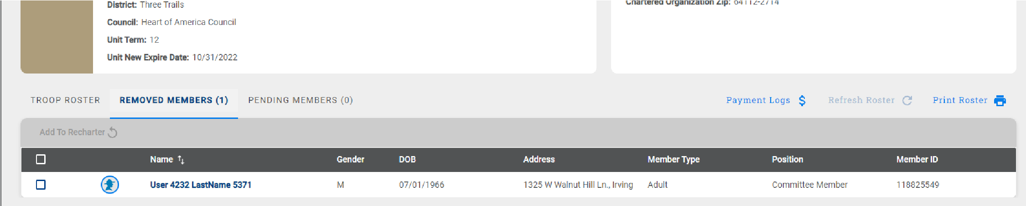

Print Your copy
You can print a copy of the charter for your records using the Print Roster button.
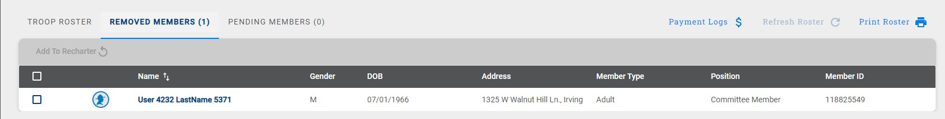

Validate Recharter and Pay
Once you have updated your roster and attached the necessary documents,
Click Refresh Roster
Click Validate Recharter and Pay
A popup will show key points (leadership in place, YPT, CBC authorization, leaders are adults)
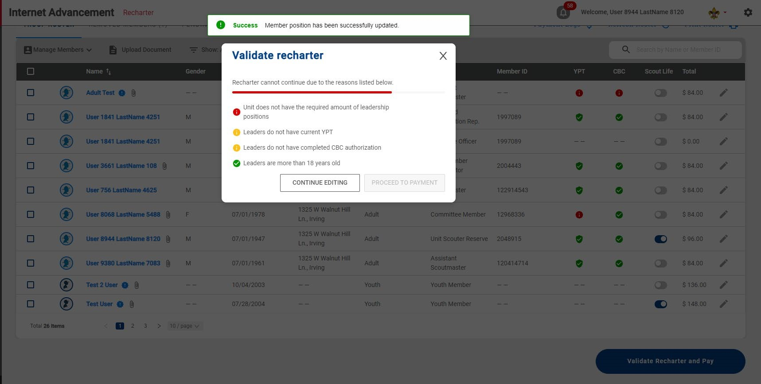
Errors must be resolved to continue
Warnings will not prevent submittal. If the missing paperwork is not submitted, a council representative will contact you.
Anything marked in green is fine – no further action is required

Error must be resolved
Council will verify warnings

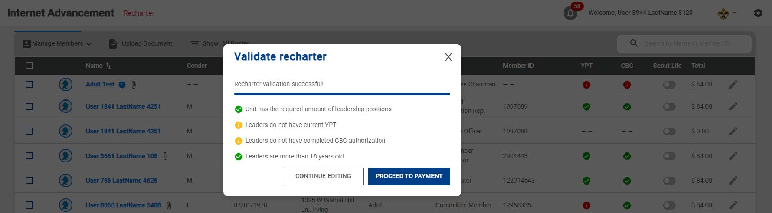

Payment and Confirmation
Please, only select the payment option PAY AT COUNCIL! This ensures that any errors or changes can be resolved quickly and easily!
As in previous years, Charter Renewal uses your Membership Escrow Account.

To add money to this account, you can:
- Call 320.251.3930, Monday through Friday, 8 am to 4:30 pm. Ask for Anna
- Mail a check to Central Minnesota Council, 1191 Scout Drive, Sartell, MN 56377 (make sure to include your unit type and number)

Any left-over funds will remain in your unit’s Membership Escrow Account for later registrations.

 | 2022 Registration Fees
 | BSA Registration | Council Fee | Scout Life (If requested)
Youth | $72/year | $9/year | $12/year
Adult | $45/year | $9/year | $12/year
Unit Charter Fee | $75

Anyone who applied using Online Registration in October through December paid for 2022
when they applied – they are noted as Pre-Paid on the charter, and you will not be charged
again, for them.

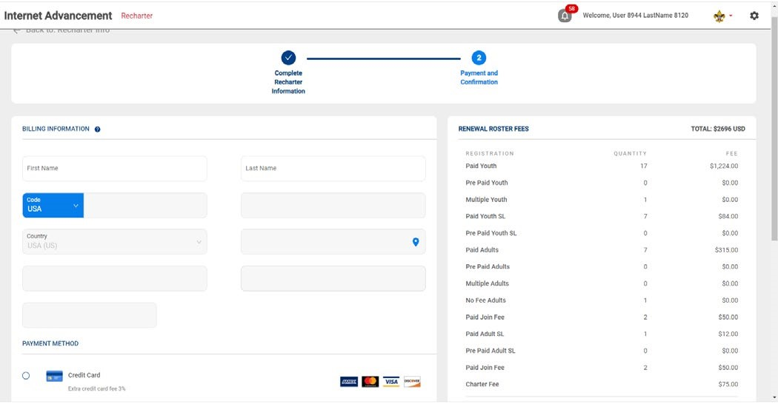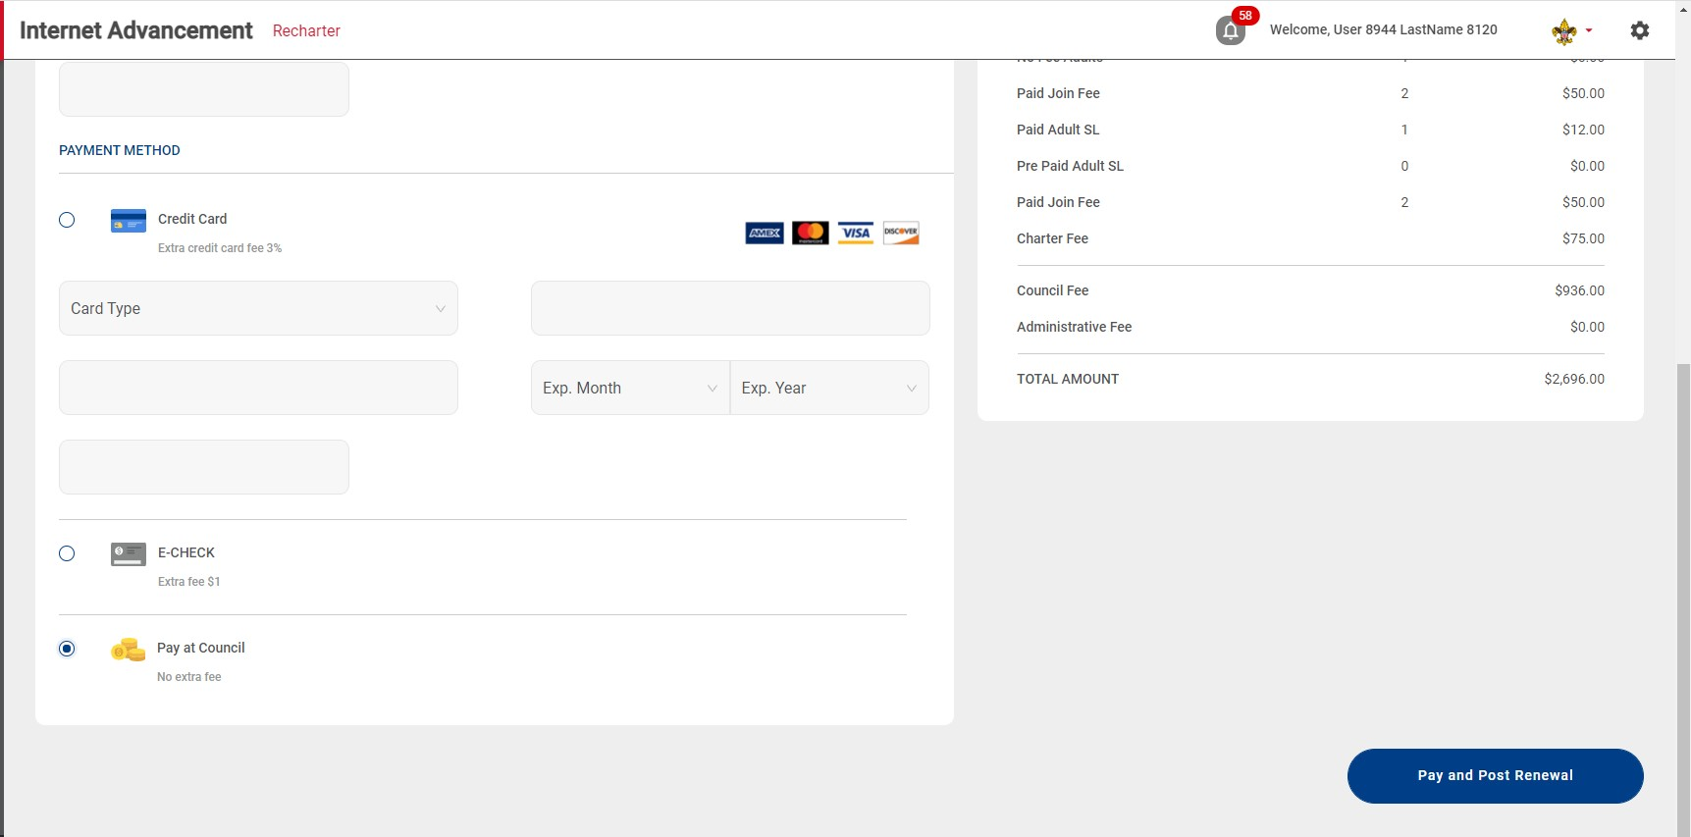

DO NOT PAY
NATIONAL
PAY AT
COUNCIL

SCROLL
DOWN

Once you have chosen your payment option, click the Pay and Post Renewal button. This will send an email to the Chartered Organization Representative for approval.

A council representative will let you know if there are any issues found with your charter during processing.

Appendix 1: Creating a Zip File for loading documents

If you are uploading a group of files, use your Zip File option by highlighting the documents, right click after highlighting the documents and select Send to and next select Compressed (zipped) folder. Once you have created the zip file and named your zip folder, choose the folder when clicking the Upload Document option.

