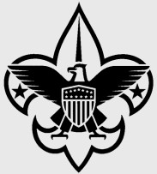
Annual District Registration Form
(January 1, 2023 – December 31, 2023)
Dear Scouter:
Your annual registration as a district volunteer is due. Please complete the form below and return to the Scout office with the appropriate fee. If you are currently registered primarily in the district or as a multiple with a unit, no adult application is required.
If you wait to complete this process until after December 31, 2022, an adult application must be completed.

Name ____________________ Date of Birth ____________

Address __________________________________________________

City ______________ State _____ Zip Code _______

Home Phone _____________ Work Phone ________________

Cell Phone ___________________________

E-mail _______________________________________

District (Choose ONE): Choose a District

District committee position(s) ______________

*Required Youth Protection Training Date Completed: ________________

Enclosed:
☐ $45.00 annual registration fee
(An adult application must be submitted if you are a new district staff.)
☐ $12.00 Insurance Surcharge
☐ $15.00 Boys’ Life subscription (optional)
☐ $0.00 (My primary registration is at the unit level
(Choose Unit Type ) #________- also serving on district staff.)

_____ Total enclosed (payable to CMC BSA)

___________________________________ ___________________________________
YOUR Signature District Executive Signature
Mail to:
Central Minnesota Council, BSA
1191 Scout Drive
Sartell, MN 56377

